J E S E N

* VRIJEME

 C:\Documents and Settings\LOVRO\Local Settings\Temporary Internet Files\Content.IE5\V92S2C77\MC900055403[1].wmf    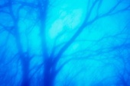

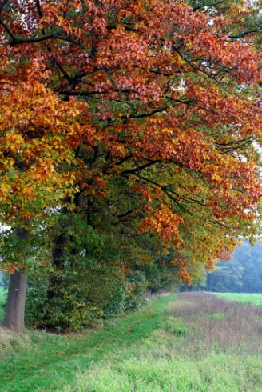

* BILJKE

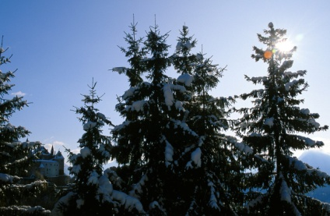

VAZDAZELENO DRVO LISTOPADNO DRVO

* ŽIVOTINJE

PTICE SELICE C:\Documents and Settings\LOVRO\Local Settings\Temporary Internet Files\Content.IE5\V92S2C77\MC900084042[1].wmf C:\Documents and Settings\LOVRO\Local Settings\Temporary Internet Files\Content.IE5\XTLTE370\MC900052616[1].wmf

STANARICE 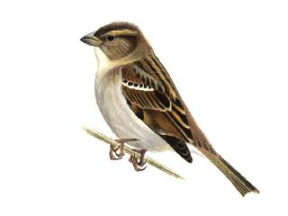 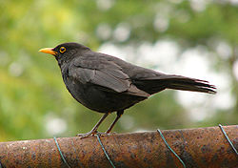

ZIMSKI SAN C:\Documents and Settings\LOVRO\Local Settings\Temporary Internet Files\Content.IE5\V92S2C77\MC900434377[1].wmf

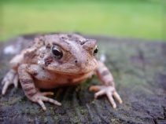 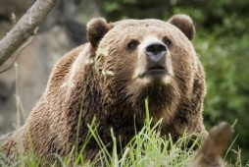 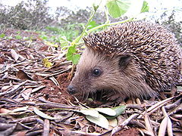 C:\Documents and Settings\LOVRO\Local Settings\Temporary Internet Files\Content.IE5\2ETWIADX\MC900016547[1].wmf

DANI SU KRAĆI A NOĆI DUŽE.